Chemical Bonding
Ques(01). What is chemical bonds?
Ques(02). How many kinds of chemical bonds are there?
Ques(03). Why do atoms combine?
Or, Wtat are the causes of chemical bonding?
Ques(04). How do atoms combine?
Or, Write down the process of bonding?
Ques(05). Write down the concept of chemical bond.
Ques(06). Write down the principles of electronic theory of chemical bond.

A chemical bond is defined as the attractive force that holds two or more atoms together in a molecule or an ion .
Example: Two atoms of hydrogen combine with each other and forms the molecule of H₂ by chemical bonding. Similarly, two hydrogen atoms and one oxygen atom combine together to form water(H₂O) molecule by chemical bonding.
Types of chemical bonds: Chemical bonds are mainly two types-
(1). Strong bonds:- (i). Ionic/Electrovalent bond,
(ii). Covalent bond,
(iii). Co-ordination bond,
(iv). Metallic bond.
(2). Weak bonds:- (i). Hydrogen bond,
(ii). Vander Walls interaction.

Why do atoms combine? (Causes of chemical bonding)
(1). Net attractive force between atoms: When the two atoms approach closer to each other, these forces counteract each other. The net result of these forces may be either attraction or repulsion between the atoms.
(2). Octate rule/rule of eight: The tendency of the atoms to have eight electrons in their outermost shell is known as octate rule.
In the formation of a chemical bond atoms interact with each other by lossing, gaining or sharing of electrons so as to acquire a stable outer-shell of eight electrons.
(3). Lowering of energy of combining atoms: The process of chemical bonding between the atoms decreases the energy of the combining atoms and gives rise to the formation of a system which has lower energy and hence has greater stability.
From the above description it is clear to us that a chemical bond is formed between the two atoms when the potentiial energy of the combining atoms is minimum and when they are at the minimum distance from each other. In order to break the bond between the atoms as much energy has to be put in as was earlier lost in the formation of the bond.
The amount of energy lost in the process of bond formation or needed to break the bond is a measure of the strength of the bond. More the energy decreased during bond formation (or, combination of atoms in a molecule), the stronger is the bond between the atoms.
How do atoms combine?(Process of bonding)
The process by which the atoms of the elements rearrange their outer-most shell electrons to get eight electron outer-most shell configuration which is a stable configuration takes place in the following ways:
(i). Transfer of one or more electrons from the valence shell of an atom to the valence-shell of another atom takes place (Ionic bond).
(ii). One ,two, or three electron pair(s) of the valence-shell of both the combining atoms are shared between them. The shared electron pairs may be contributed equally by both the atoms (Covalent bond).
or,
may be contributed by only one of the combining atoms (Co-ordination bond).
Concept of chemical bond:-
The classical concept of chemical bond formation has been largely replaced by the electronic concepts and the modern progress in the field of structural chemistry presents a great landmark.
The electronic concept:-
Electrons play a very important role in the formation of chemical bonds. The electronic concept of chemical bond was advanced by W. Kossel and G.N.Lewis in 1916 independently.
As regards the electronic arrangements we have classified atom into four(4) groups:
(¡). Atoms with complete electronic groupings,
(¡¡). Atoms having all but the outer-most electronic trouping incomplete,
(¡¡¡). Atoms having two outer-most electron levels incomplete,
(¡v). Atoms with three outer-most energy level incomplete.
Principle of Electronic Theory of Chemical Bond :-
(1). Chemical combination between atoms of the same or different elements take place due to the tendency by the outermost electron groups to attain the stable arrangement of inert gases.
(2). The attainment of inert gas electron configuration may take place by complete transference of electrons from one atom to another. The resulting electrically charged atoms(or, ions) are held together by electrostatic force of attraction. The chemical bond so formed is known as electrovalent or ionic bond.
(3). The attainment of inert gas configuration may occur by sharing of electrons (in pairs) between two atoms. The chemical bond so formed is known as covalent bond.
(4). The attainment of electron groupings of inert gases may also happen by both transference and sharing of electrons between atoms in pairs.The bond so formed is known as co-ordination bond.

Ques(07). What is ionic/electrovalent bond?
Ques(08). Write down the Necessary Conditions for Ionic Bond Formation.
Ques(09). What are the limitations to form ionic/electrovalent bond.
Ques(10). Explain the deviation from the rule of octate in ionic compounds.

Ionic bond/Electrovalent bonds:
When metal and non-metal react each other , metal losses it’s outermost electron(s) and form cation(positive charged) and non-metal gain the losses electron(s) and form anion (negative charged). The bond formation between these anion(s) and cation(s) by electrostatic attraction is called ionic bond/ electrovalent bond.
Example: NaCl, MgO, CaCl₂ , Na₂O, Al₂O₃ , etc.
Necessary Conditions for Ionic Bond Formation:
The pre-condition to form ionic bond is to form cation(s) and anion(s) and electrostatic attraction between these opposite charges to form lattice. These 3 conditions to form ionic bond is as follows:
(i). Low ionizaation energy of metal: Energy required to form possitive ion (cation) by losing electron to infinitive distance is called ionization energy .
Na_{(g)} + 496 KJ → Na⁺_{(g)} + e⁻
Lower the ionization energy of metal , higher is the tendency to form cation, hence more frequently form ionic bond.
(ii). High electron affinity of non-metal: Energy evolved to form negative ion (anion) by gaining electron in it’s outermost shell is called electronegativity of that atom.
Cl_{(g)} + e⁻ → Cl⁻_{(g)} + 394 KJ
Higher the electron affinity of non-metal, higher is the tendency to form anion, hence more frequently form ionic bond.
(iii). High lattice energy: The energy evolved during the formation of 1 mole lattice by joining positive (cation) and negative (anion).
Na⁺_{(g)} + Cl⁻_{(g)} → NaCl + 760 KJ.
Higher the lattice energy , higher is the stability of ionic compound.
Limitations of ionic bond:
Ionic bonds only occurs between metals and non-metals. But it is impossible to form ionic bonds between only metal and metal or only nonmetal and nonmetal.
Deviation from octate rule in ionic compounds:
Every alkali metals or alkaline earth metals produce ionic compound following the octet rule.
On the other hand, transitional metals or d-block atoms and inner transitional metals or f-block atoms also produce ionic bonds. Generally they loss electron and produce cation. To obtain inert gas electronic configuration there require more electron to loss or regain(for d-block and f-block atoms), for which huge amount of energy is produced but it is not possible.
So, generally they loss 2/3 electrons to produce M²⁺/M³⁺ ions and sometimes M⁺/M⁴⁺ also. In these ions no one can fulfill their octet electronic configurations in their outermost shell.
Fe(26) →1s². 2s². 2p⁶. 3s². 3p⁶. 3d⁶. 4s²
Fe2+ →1s². 2s². 2p⁶. 3s². 3p⁶. 3d⁶
Fe3+ →1s². 2s². 2p⁶. 3s². 3p⁶. 3d⁵

Ques(11). What is covalent bond?
Ques(12). Write down the deviation of rule of octate or limitations of Lewis concept.
Ques(13). What is the rule of two in covalent bond?
Ques(14). How many types of covalent bond?
Ques(15). Write down the Difference between ionic compounds and covalent compounds.
Covalent bond:
The chemical bond between two atoms (mainly non-metal atoms) in which the electrons in pairs are shared by both the participating atoms is called covalent bond.
The paired electrons are shared by both the atoms and circulate about the nuclei of both the atoms. Each of the two combining atoms contributes one electron to the electron pair.
The covalent bond is established between the atoms of the same or different elements.
Example: H─H bond,
O=O bond,
N Ξ N bond.
Deviation from octet rule/ Limitations of Lewis concept:
There are many covalent molecules in which the central atom which is covalently bonded with other atoms has electrons either less than eight (incomplete octet) or more than eight (expansion of octet) in it’s outermost shell.
(1). Molecules in which the octet remains incomplete(Incomplete octet):
(a). BeCl₂-molecule: In this molecule Be atom (central atom) has only 4 electrons in it’s outermost shell-2 of it’s own and the other 2 from the two covalently bonded Cl-atoms.
(b). BF₃-molecule:In this molecule B atom (central atom) has only 6 electrons in it’s outermost shell- 3 of it’s own and the other3 from the three covalently bonded F atoms.
(2). Molecules in which the octet is expanded (Expansion of octet):
Consider the structures of PCl₅ , ClF₃ , ICl₃ , SF₆ , IF₇ , OsF₈ , OsO₄
molecules:
Rule of two in covalent bond:
According to this theory, if an atom contain unpaired electron then it combine with another unpaired electron of another atom and form a paired electron and thus form covalent bond.
Exam: (1). NH₃ molecule formation: N(7) →1s². 2s². 2Px¹.2Py¹. 2Pz¹
From the electronic configuration of nitrogen(N) it is shown that N contains 3 unpaired electrons. Hydrogen(H) also contains 1 unpaired electron. Therefore, N-combines with three H-atoms to form 3 unpaired electrons, thus NH₃ molecule is formed.
(2). N₂-molecule formation:

(3). H₂O-molecule formation:

Types of covalent bond:
There are 2 main types of covalent bond
(1). Non-polar covalent bond (Covalent bond between two similar atoms):
A covalent bond between two similar atoms which have the same electronegativity or zero electronegativity difference and in which electrons are shared equally between the linked atoms is called a non-polar covalent bond.
Example: H─H , Cl─Cl , F─F.
(2). Polar covalent bond (Covalent bond between two dissimilar atoms):
A covalent bond between two dissimilar atoms which have different electronegativity values and in which electrons are shared unequally between the linked atoms and the linked atoms acquire fractional positive and negative charge is called a polar covalent bond.
Example: H─F , H─Cl , H─O─H.

Difference between ionic compounds and covalent compounds:
Properties | Ionic Compound | Covalent Compound
(1).Physical state | Crystalline solid | Gases/liquid
(2).Hardness/Brittleness | Hard and brittle | Soft and waxy
(3).Nature of reaction | Ionic- fast- instantaneous | Moleculer- slow
(4).m.p/b.p | high | Low
(5).Solubility | Soluble in water | Insoluble in water
(6).Conductivity | Bad condc.-solid  Good con.-fused/liquid | Poor conductors
(7).Nature of bonds | Transfer of e-  Metal + nonmetal | Sharing of e-  Nonmetal + nonmetal
(8).Isomerism | Not show | show

Ques(16). What is sigma (-σ) bond and pi(-π) bond?
Ques(17). Write down the differences between σ-bond and π-bond.
sigma (-σ) bond:
A covalent bond resulting from the formation of a molecular orbital by the end-to-end overlap of atomic orbitals, denoted by the symbol σ.
Now have a look at this illustration to see how this end-to-end overlapping occures:
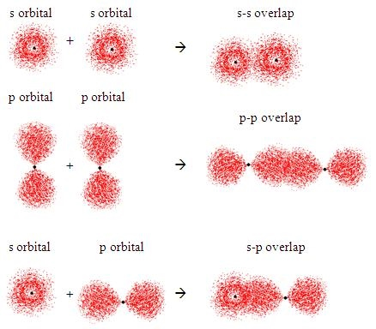
To understand Sigma bonding let us look at the simple molecule of methane (CH₄).
Methane (CH₄)
We may all be familiar with drawing methane using electron dot diagrams, which would look something like this:

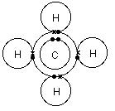
For now, let us ignore the Hydrogen and concentrate on the central Carbon atom. We know that it is the valence electrons that are responsible for covalent bonding and we must know the electron configuration of an element from the periodic table to know how many valence electron it has.
Now, when we look at the carbon atom from our Methane, we see that its electron configuration is 1s² 2s² 2p². However, from this electron configuration we can see that carbon has only two unpaired electrons (2p²) in its valence shell which can be used to form bonds with two hydrogen atoms. You can see this more clearly in the electrons-in-boxes notation below.
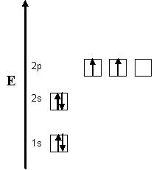
Fig 3: Energy diagram for Carbon

So why is methane written as CH₄ and not CH₂? Well the answer to this lies in something know as hybridization.
Pi(-π) bond:
When sideways overlapping or lateral overlapping of the two atoms take place is known as lateral overlap of their ‘p’ orbital, and the bond formed is known as covalent pi (π) bond. The electron density is concentrated in the region perpendicular to the bond axis in a pi bond.
Due to partial overlapping of orbital, the bond formed which is pi is weak. If the ‘p’ orbitals are parallel then there will be complete sideways overlapping and hence the pi bond will be strong. This can be possible only when the atoms involved of the molecule are in the same plane. This means there is no rotation of the atom with respect to other which is formed on pi bond.
π is a Greek letter. It is known as π because it is formed by p-orbital.
To understand pi bonding lets have a look at the simple molecule of Ethene C₂H_{4.}
You may have drawn the ethane molecule many times in your classrooms and we are all aware of how the atoms and bonds are drawn to represent this molecule. Usually is would look something like this:
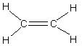
Fig 7: Structure of Ethene
In the case of Ethene, there is a difference from methane or ethane, because each carbon is only joining to three other atoms rather than four. When the carbon atoms hybridise their outer orbitals before forming bonds, this time they only hybridise three of the orbitals rather than all four. They use the 2s electron and two of the 2p electrons, but leave the other 2p electron unchanged.
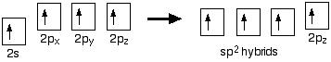
Fig 8: sp² hybridisation
The new orbitals formed are called sp² hybrids, because they are made by an s orbital and two p orbitals which have reorganised themselves. sp² orbitals look much like sp³ orbitals that you have already come across in the bonding in methane. The three sp² hybrid orbitals arrange themselves as far apart as possible, which is at 120° relative to each other in a plane and remaining p orbital is at right angles to them.
The two carbon atoms and four hydrogen atoms would look like this before they joined together:
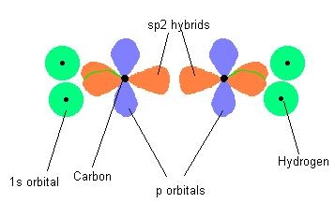
Fig 9: 1s and sp² hybrid orbitals
The various atomic orbitals which are pointing towards each other now merge to give molecular orbitals, each containing a bonding pair of electrons. These are sigma bonds - just like those formed by end-to-end overlap of atomic orbitals that we saw in methane and ethane
The p orbitals on each carbon aren't pointing towards each other, are overlapping sideways.
This sideways overlap also creates a molecular orbital, but of a different kind. In this one the electrons aren't held on the line between the two nuclei, but above and below the plane of the molecule. A bond formed in this way is called a pi bond. Look at this illustration and notice how the orbitals have arranged themselves to form the pi bonds:

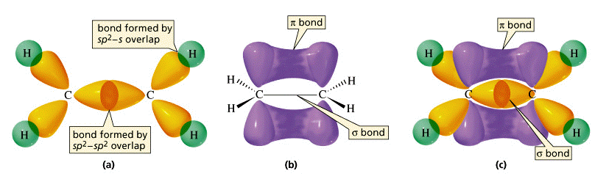
Fig 10: Sigma and pi bonding in Ethene.
Differences between σ-bond and π-bond:
σ-bond | Π-bond
(1). The extent of overlapping of orbitals along the nuclear axis is relatively greater | (1). The side-wise overlap of two p-oorbitals which gives a π-bond is partial.
(2). More stronger bond | (2). More weaker bond.
(3). Overlapping is in head-to-head manner. | (3). Overlapping is in side-to-side/lateral manner.
(4). Probability of finding the e- between the nuclei(on the bond axis) is maximum. | (4). Poor/minimum.
(5). Electrons are distributed symmetrically. | (5). Electrons are distributed unsymmetrically.
(6). Free rotation is possible.  (7). Occur in hybrid/pure orbitals. | (6). not possible  (7). Occurs only in pure orbitals.

Ques(17). What is Co-ordinate/Co-ordinate covalent/Dative bond?
Ques(18). Write down the Conditions for the formation of a co-ordinate bond.

Co-ordinate/Co-ordinate covalent/Dative bond:-
A covalent bond which is formed by the mutual sharing of two electrons both of which are provided entirely by one of the linked atoms (ions) is called a co-ordinate bond.
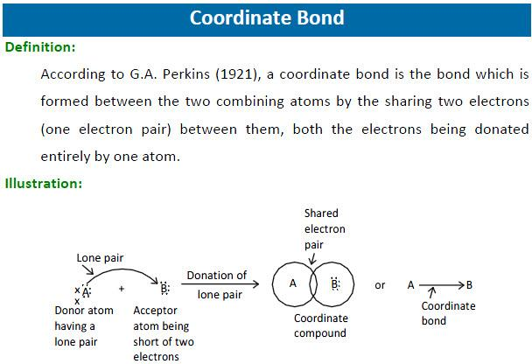
The pair of shared electrons is called lone pair. The atom which furnishes the electron pair is called donor/ligand, while the other atom which accepts the electron pair is called acceptor.
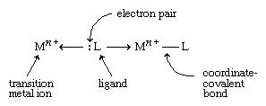
A co-ordinate bond is represented by an arrow(→) which points away from the donor to the acceptor.
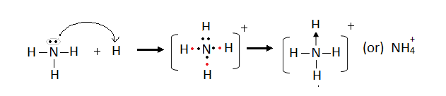
Conditions for the formation of a co-ordinate bond:
(1). The atom acting as a donor should have a lone pair of electrons.
(2). The atom acting as an acceptor should have a vacant orbital to accept the electron pair donated by the donor.
Example:
(i). NH₄⁺ molecule : 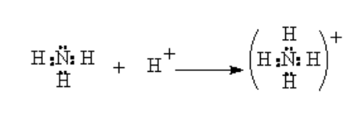

(ii). H₂O₂ molecule
(iii). BF₄⁻ molecule : 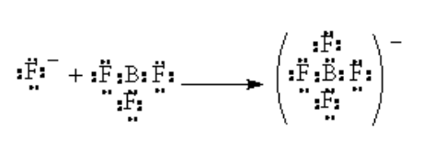
(iv). SO₄²⁻ ion :
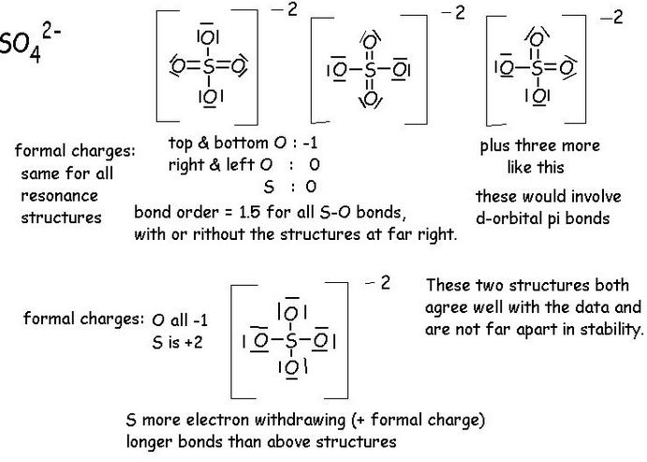

Ques(19). Indicate and explain the presence of different types of bonds in the following compounds:
NH₄Cl , Ag(NH₃)₂Cl , Na₂SO₄ , KBF₄⁻ , Co(NH₃)₆Cl₃
Ques(20). Explain the ionic character of covalent compounds.
Ques(21). Explain the covalent character of ionic bond (Fajan’s rule).
Ques(21). Explain the covalent character of ionic bond (Fajan’s rule).
Ques(22). What is Distortion/Deformation/Polarization of ions?
Ques(23). Write down the factors affecting polarizability.

Presence of different types of bond in the same compound:-
There have many compound in which various kinds of bonds are contained.
Such as: NH₄Cl , Ag(NH₃)₂Cl , Na₂SO₄ , KBF₄⁻ , Co(NH₃)₆Cl₃
Ionic character of covalent compounds:-
According to Lewis theory, in covalent compounds electron pair is uniformly shared between the atoms engaged in covalent bond. But in reality, depending on the difference in electronegativity of 2 non-metal atoms, the covalent character deviates and turn to ionic character. i.e., (¡). When difference of electronegativity is 0 →Pure covalent compound Example: H₂ , F₂ , Cl₂.
(¡¡). When difference of electronegativity is less than 0.5 →Non-polar covalent compound Example: CH₄ , C₂H₆ , C₆H₆.
(¡¡¡). When difference of electronegativity is in between 0.5-1.7→Polar covalent compound (ionic in character)
Example: HCl
(¡v). When difference of electronegativity is higher than 1.7→Mainly ionic Example: HF
Distortion/Deformation/Polarization of ions:-
When a cation(C⁺) of an ionic molecule(C⁺A⁻) approaches closely the anion(A⁻), it withdraws the electrons(i.e., electron cloud) of the anion towards itself and the electron cloud of the anion gets distorted from it’s symmetrical shape. Thus the electron cloud of the anion no larger remains symmetrical but is elongated towards the cation.
In otherwords , we can say that the anion(A⁻) is distorted(deformed/polarized) by cation(C⁺) and this phenomenon is called distortion(deformation/polarization) of anion(A⁻) by cation(C⁺).
The ability of a cation to polarize a nearby anion is called it’s polarizing power or polarizing ability and the tendency of an anion to get distorted or polarized by a cation is called it’s polarizability.
Factors affecting polarizability:
(¡). Size of cation and anion,
(¡¡). Charges of cation and anion,
(¡¡¡). Electronic configuration of the cation .
Covalent character of ionic bond (Fajan’s rule):
The tendency of an anion to form covalent compounds depends on the magnitude of it’s tendency to be polarized by a given cation , i.e., on it’s polarizability. Greater is it’s polarizability, greater is it’s tendency to give covalent molecule.
According to Fajan’s rule, the polarizability increases when-
(¡). The charge either on cation or an anion become large.
Example: LiCl<BeCl₂<BCl₃<CCl₄
(¡¡). The size of the cation should be small.
Example: BaCl₂<SrCl₂<CaCl₂<MgCl₂,BeCl₂
(¡¡¡). The size of the anion become large.
Example: CaF₂<CaCl₂<CaBr₂<CaI₂
HF<HCl<HBr<HI
(¡v). The cation having 18-electrons in valence-shell configuration.
Example: CuCl is more covalent than NaCl.
AgI is covalent while NaI is ionic.

Ques(24). What is metallic bond?
Ques(25). How are the metal atoms in metal crystal bonded together?
Ques(26). Write down the properties of metallic bond.
Ques(27). Why the electrical conductivity of most of the metals decreases with the increase of temperature ?
Ques(28). Why metal is ductile in nature ?
Ques(29). What is photo-electric effect ?Why metal shows this effect ?
Ques(30). Why metallic bond is weaker than covalent bond ?

Metallic bond:
The peculiar type of bonding which holds the metal atoms together in a metal crystal is called metallic bonding.
The process by which the metal atoms in a metal crystal bonded together:
Ans: The process/nature of metallic bonding was first proposed by Drude(1900) and later on developed by lorentz(1916), is known as electron-cloud or electron-pool or electron-gas theory.
Since the ionization energy of metals are low, they readily give up their valence electrons to form the metal ions (called positive cores/kernels).
A metal is regarded as a group of positive metal ions packed together as closely as possible in a regular geometric pattern and immersed in a sea of electrons(called electron-pool/electron-gas/electron-cloud) which move about freely in the vacant valence orbitals.
The attractive force that binds the metal ions to the mobile electrons is called metallic bond and the force of attraction between the metal ions and the mobile electrons holds the atoms together.
Properties of metals:
(¡). Metals are good conductors of electricity (Electrical conductivity),
(¡¡). Metals are good conductors of heat (Thermal conductivity),
(¡¡¡). Metals are opaque and have lustre/colour,
(¡v). Metals are malleable or plastic or ductile,
(v). Metals have elasticity,
(v¡). Metals are usually hard solids,
(v¡¡). Metals can emit electrons (photo-electric effect).

Ques(31). What is hydrogen bond?
Ques(32). How many types of hydrogen bond?
Ques(33). Explain inter-molecular and intra-molecular hydrogen bond with suitable examples.
Hydrogen bond:
The attractive electrostatic force between a hydrogen atom which is already covalently attached with a strongly electronegative atom of a molecule and another electronegative atom of some other molecule (same molecule or different molecule) is called hydrogen bond.
Types of hydrogen bond:
Hydrogen bond is two types:- (¡). Inter-molecular hydrogen bond (Association)
(¡¡). Intra-molecular hydrogen bond (chelation)
(1). Inter-molecular hydrogen bond:
This type of hydrogen bond occurs between two or more molecules of the same of different compounds. Thus NH₃ , H₂O and HF molecules are associated by inter-molecular H-bond.
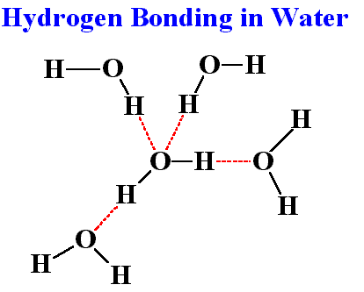

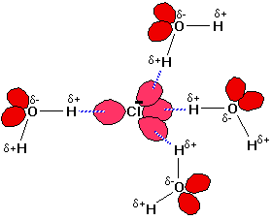
(2). Intra-molecular hydrogen bond(chelation):
This type of hydrogen bond is formed between a H-atom and an electronegative atom present in the same molecule. In intra-molecular hydrogen bonding, the hydrogen atom is bonded to two atoms of the same molecule. 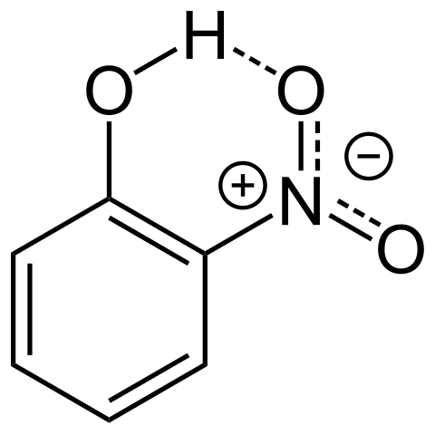
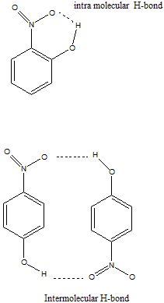

Ques(34). What is hybridization?
Ques(35). Write down the conditions for the hybridization of atomic orbitals.
Ques:( 36). What will be the shapes of the molecules when the central elements will have the following types of the hybridization ?
Hybridization:
The process of mixing pure atomic orbitals on an atom of nearly equal energy to produce a set of entirely new orbitals which are equal in number to the mixing orbitals have the same energy and identical shapes and are symmetrically disposed in space round the atom is known as hybridization
and the new orbitals produced are called hybrid orbitals or simply hybrids.
The conditions for the hybridization of atomic orbitals:
(¡). Orbitals on a single atom only would undergo hybridization,
(¡¡). There should be very little difference of energy level between the orbitals mixing to form hybrid orbitals,
(¡¡¡). Numbers of hybrid orbitals generated is equal to the number of hybridizing orbitals,
(¡v). The hybrid orbitals assume the direction of the dominating orbitals,
(v). It is the orbitals that undergo hybridization and not the electrons,
(v¡). The electron waves in hybrid orbitals repeal each other and thus tend to be farthest apart.

Shapes of the molecules when the central elements will have the following types of the hybridization :
(1). Sp³-hybridization: CH₄→109˚28̕ →Tetrahedral
NH₃→107˚ →Triangular pyramidal
H₂O→104.5˚ →V-shape(angular shape)

(2). Sp²-hybridization: BCl₃ →120˚ → Triangular (planner)
C₂H₄→120˚ → Triangular (planner)

(3). Sp-hybridization: BeCl₂ →180˚ → Linear
C₂H₂ →180˚ → Linear

(4). dsp²-hybridization:- Square planner shape

(5). dsp³-hybridization:- Triangular bi-pyramidal shape

(6). d²sp³-hybridization:- Square planner bi-pyramidal (Octa-hedral)

(7).d³sp³-hybridization:- Pentagonal bi-pyramidal.

Ques:(37 ). Describe the uniform four valency of carbon.
C₍₆₎ →1s².2s².2p²
C₍₆₎ →1s².2s².2P_{x}¹.2P_{y}¹.2P_{z}⁰
Since, C₍₆₎ has two unpaired electron in outermost p-orbital. So, it should be divalent i.e., one C-atom should combine with two H-atoms to form CH₂ not CH₄. But in reality CH₂ is unstable whereas CH₄ is a very stable compound. So C must posses four unpaired electron during formation of methane(CH₄).
In excited state (after absorbing some energy), C₍₆₎ will have the following electric configurations.
C*₍₆₎ →1s².2s¹.2P_{x}¹.2P_{y}¹.2P_{z}¹
In excited state C has 4 unpaired electrons which permit the mixing process. Atomic orbitals of almost equal energy can hybridized to form equal number of hybridized orbital of same energy. In this case one 2s orbital and three 2p orbitals can hybridized orbitals of same energy.
The hybridized orbital should have tetrahedral arrangement as shown below:
C₍₆₎ →1s². 2s¹ . 2P_{x}¹ . 2P_{y}¹ . 2P_{z}¹
(2sp³)¹.(2sp³)¹.(2sp³)¹.(2sp³)¹
2Ψ¹. 2Ψ¹. 2Ψ¹. 2Ψ¹
(sp³-hybridization)
In the hybridized orbitals, the total electrons present in the atomic orbitals, which undergoes hybridization is distributed accordingly to the Hund’s rule.

Structure of methane, ethane etc.(paraffin):
In excited state C has 4 unpaired electrons which permit the formation of methane(CH₄) by pairing each unpaired electrons of carbon by 4 different 1s¹ electrons of hydrogen atom as shown below.
C*₍₆₎ →1s² . 2s¹ . 2P_{x}¹ . 2P_{y}¹ . 2P_{z}¹
1s¹ 1s¹ 1s¹ 1s¹
H H H H

Ques(38). What is Valence Shell Electron Pair Repulsion-theory (VSEPR-theory)?
Valence Shell Electron Pair Repulsion-theory (VSEPR-theory):
This is a very small useful theory to predict the geometry or shape of a number of polyatomic molecules/ions of non-transition elements. This theory says that,
“The shape of a given species (molecule/ion) depends on the number and nature of electron pairs surrounding the central atom/ion of the species.”
This theory makes the following assumptions:
(1). Special arrangement of electron pairs round the central atom/ion of a given molecule/ion,
(2). Regular and irregular geometry of the molecule/ion.
The change in the magnitude of bond angle due to the fact that (lp-lp) repulsion is greater than (lp-bp) repulsion which in tern is greater than (bp-bp) repulsion.

lp-lp repulsion> lp-bp repulsion>bp-bp repulsion.
Ques(39). Why the bond angle of NH₃ is 107˚, but the bond angle of NH₄⁺ is 109˚28̕ ?
Ans: The Lewis structure of NH₃ shows that the central N-atom has 3 bonding electrons and 1 lone pair electron. The VSEPR-theory says that these electron pairs are directed to the converts of a tetrahedron. Thus we predict the H-N-H bond angle should be 109˚28̕. According to the VSEPR-theory, a lone pair exerts greater repulsion on the bonding electron pairs than the bonding pair do on each other i.e., lp-bp repulsion> bp-bp repulsion.
As a result the bonds of NH3 molecule are pushed slightly closer and the observed bond angle of H-N-H is 107˚ instead of 109˚ predicted from the tetrahedral structure.

But the N-atom in NH₄⁺ has 4 bonding electron pairs in the valence shell. The VSEPR-theory says that these e- pairs are directed to the corner of a tetrahedral. So, the bond angle is 109˚28̕ .Here, lp-lp repulsion is not involved. So, it is tetrahedral structure.
Ques(40). Explain why BeCl₂ is linear but SnCl₂ is “V”-shaped.
Ques(41). Explain why the bond angle of H2O become 104.5º instead of 180º?

2s and 2P_{z} orbitals of Be atom in the excited state hybridized together and create 2 new equivalent orbitals which are known as sp hybrid orbital and the shape of sp hybrid orbital is linear. So, the structure of BeCl₂ is linear.
Similarly, in the formation of SnCl₂
Sn₍₅₀₎ →1s² . 2s²p⁶ . 3s²p⁶d¹⁰ . 4s²p⁶d¹⁰ . 5s².P_{x}¹.P_{y}¹.P_{z}⁰
“Sn” has 4 valence shell electrons in forming 2 σ-bonds with 2Cl atoms while remaining 2 electrons remain as non-bonding electrons.
Here 2 orbitals are hybridized. So, it is sp hybridization.But Sn has 1 electron pair. So, according to (lp-bp)-repulsion 2(Sn-Cl) bonds are pushed closer to each other and SnCl₂ molecule become “V”-shaped.

Ques(42). What is lattice energy?
Ques(43). Though the ionization potential of Na is greater than electron affinity of Cl, why they form spontaneously NaCl- crystal ?
Or, Why the formation of NaCl is spontaneous if though the ionization potential of Na is greater than the electron affinity of Cl ?
Or, How much the lattice energy of NaCl?
Or, What is the value of Hf in the formation of NaCl ?

Ques(44). Explain why MgCl₂ rather than MgCl is formed when Mg reacts with Cl₂ at ordinary temperature.
Ques(45). Explain why H2O is liquid but H2S is gas at ordinary temperature?
Ques(46). What is bond order(B.O.)?
Ques(47). What do you mean by Valence Bond Theory (VBT)?
Ques(48). What do you mean by Molecular Orbital Theory (MOT)?
Ques(49). Calculate the bond order (B.O.) of –
(i). Helium (He₂)
(ii). Neon (Ne₂)
(iii). Fluorine (F₂)
(iv). Nitrogen (N₂)
(v). Oxygen (O₂)
(vi). Nitrogen oxide (NO)
Ques(50). From the calculation of BO, explain the magnetic properties of the following compound:
(i). Helium (He₂)
(ii). Neon (Ne₂)
(iii). Fluorine (F₂)
(iv). Nitrogen (N₂)
(v). Oxygen (O₂)
(vi). Nitrogen oxide (NO)

Lattice energy: Lattice energy is the amount of energy liberated during the formation of 1 gm mole of an ionic crystal from their related ions.
Bond Order:
Bond order is defined as one half of the difference between the number of electron in bonding molecular orbitals and anti-bonding molecular orbitals.
Bond Order(B.O)=
B.O=(Nb-Na)/2

